**If you observe the following**:-

* Feel a bulge or a lump through touch.
* Experience chest pain and discomfort like acid reflux and difficulty in swallowing.
* Pain, heaviness and weakness in the affected area –while bending, coughing or lifting weights.
* Nausea or vomiting…

You may have **HERNIA.**

**WHAT IS HERNIA ?**

A **HERNIA** occurs when an organ or fatty tissue squeezes through a weak spot in a surrounding muscle or connective tissue called **fascia**. It is the abnormal exit of tissue or an organ, such as the bowel, through the wall of the cavity in which it normally resides**. Hernias** come in a number of different types. Basically it is a bulging of an organ or tissue through an abnormal opening. Most commonly they involve the abdomen. In India, It is very common; there are more than 10 million cases per year.

**HOW TO RELIEVE HERNIA PAIN??**

* Use ice packs.
* Take medication to manage pain.
* Take medication to treat reflux.
* Wear a support or truss.
* Try acupuncture.
* See a doctor immediately if you are experiencing severe pain.
* Get surgery.

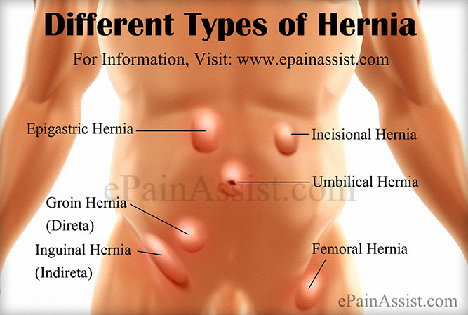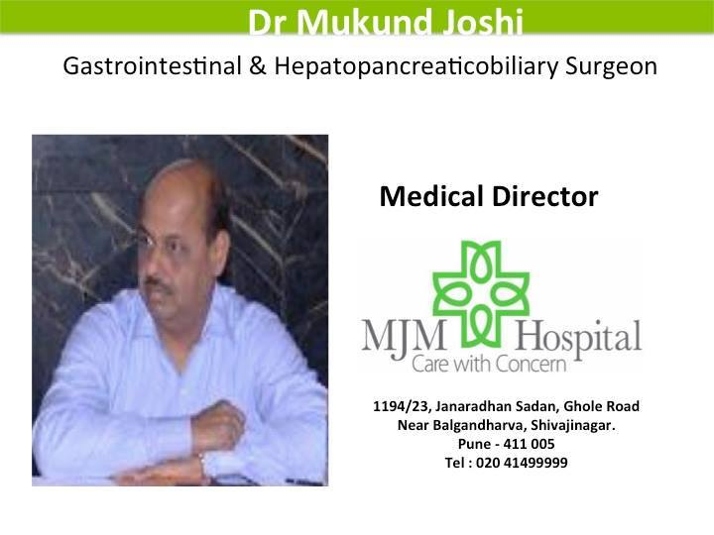

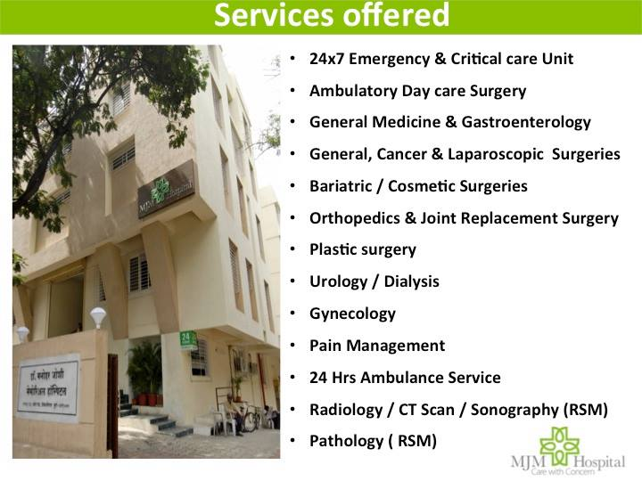

**MJM Hospital** runs **“HERNIA CLINIC”** in their hospital at Ghole Road, PUNE. The hospital has special programs to help patients in detecting and treating hernia.

For more details contact: 09769337236